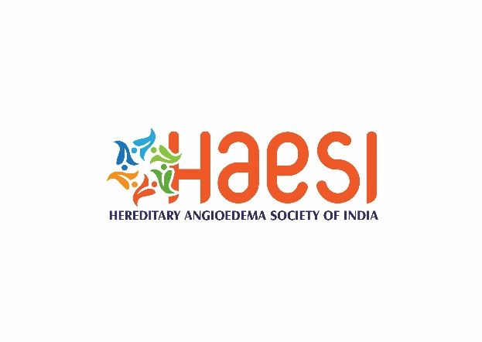 **Membership Application Form**

**Photograph**

**Hereditary Angioedema Society of India (HAESI)**

Name…………………………………………………………………Gender (M/F) ………

Age…………………………………………… Date of Birth…………………………………………………………….

Nationality…………………………………………………………………………………………………………………….

Qualification (Send a self-attested scanned copy of the highest degree) ………………………..

Speciality.............................................................................................................................

Current position…………………………………………………………………………………………………………….

Name of Hospital/Institute…………………….……………………………………………………………………….

Address for correspondence……………………………………………………………………………………………

………………………………………………………………………………………………………………………………………

Mobile number………………………………………………………...………………………………………………….

Email ID: ……………………………………………………………………………………………………………………….

Type of membership: Founder/Life/Associate/Corporate/ Institutional

Medical Registration number…………………………………………………………………………………………

Details of the payment (Cheque/Demand draft/NEFT) ………………………………………………….

… **Membership fee: Founder members: INR 5,000; Life members: INR 3,000 A Associate members: INR 500/year; Corporate members: INR 50,000/year**

*I hereby apply for the membership of Hereditary Angioedema Society of India (HAESI). I agree to abide by the rules and regulations of the society. I certify that the details submitted by me are true and any false information may entail cancellation of my membership from the society*.

Signature………………………………………………………. Date…………………………………………….

**Please send the Demand Draft/Cheque to following address:**

Dr. Ankur Kumar Jindal, Room no. 4116, 4th Floor A Block, Allergy Immunology Unit, Department of Pediatrics, Advanced Pediatrics Centre, PGIMER, Sector-12, Chandigarh- 160012, Mobile: +91-95920-65559

Email: [ankurjindal11@gmail.com](mailto:ankurjindal11@gmail.com);

[haesocietyofindia@gmail.com](mailto:haesocietyofindia@gmail.com)

Name of Account: Hereditary Angioedema Society Chandigarh HASC

Account Number: 40149338861

Name of Bank: State Bank of India

Branch: Medical Institute Branch

Address: Sector-12, Chandigarh

IFSC code: SBIN0001524

***Terms and conditions:***

**Founder members:**

Medical Practitioners holding allopathic qualifications (basic MBBS degree) recognized under schedule I or III of the Indian Medical Council Act 1956 and interested in the science and art of Hereditary Angioedema (HAE) or Non-medical scientists (PhD/MSc) with a research interest in HAE who would initially contribute to the development of the upcoming society will be considered Founder Members. The first set of office bearers will be selected from amongst the Founder Members. Tenure of new office bearers will be for minimum two years. The duration can be changed, in exceptional circumstances, as per the decision of general body.

**Associate Members:**

Paramedical staff, non-medical scientists other than research workers, Philanthropists / donors / spouse of Life Members and interested family members of HAE would only be eligible for the associate membership of the society. Their name(s) is/are unanimously recommended by the managing committee and passed by a two-third majority at a meeting of the general body. An Associate Member shall be entitled to participate in all the activities of the society, but he/she shall not be entitled to either vote at a meeting of the society or become an office bearer.

**Life Members:**

Those who are eligible for membership on paying an amount equivalent to 10 times of the initial joining fee can acquire life membership. Medical Practitioners holding allopathic qualifications recognized under schedule I or III of the Indian Medical Council Act 1956 and interested in the science and art of HAE shall be eligible for membership.

**Honorary Members:**

Any individual who has rendered outstanding service to the field of HAE to this membership provided his/her name is unanimously recommended by the managing committee and passed by a two-third majority at a meeting of the general body. An Honorary Member shall be entitled to participate in all the activities of the society, but he/she shall not be entitled to either vote at a meeting of the society or become an office bearer.

**Corporate Members:**

Representatives from the corporate sector willing to sponsor the activities of HAE would be eligible to become Corporate Member provided their name(s) is/are unanimously recommended by the managing committee and passed by a two-third majority at a meeting of the general body. A Corporate Member shall be entitled to participate in all the activities of the society, but he/she shall not be entitled to either vote at a meeting of the society or become an office bearer.

**Institutional Members:**

Representatives of other societies, organizations, foundations etc. would be invited to become institutional members of the Association. They shall have no right to vote.